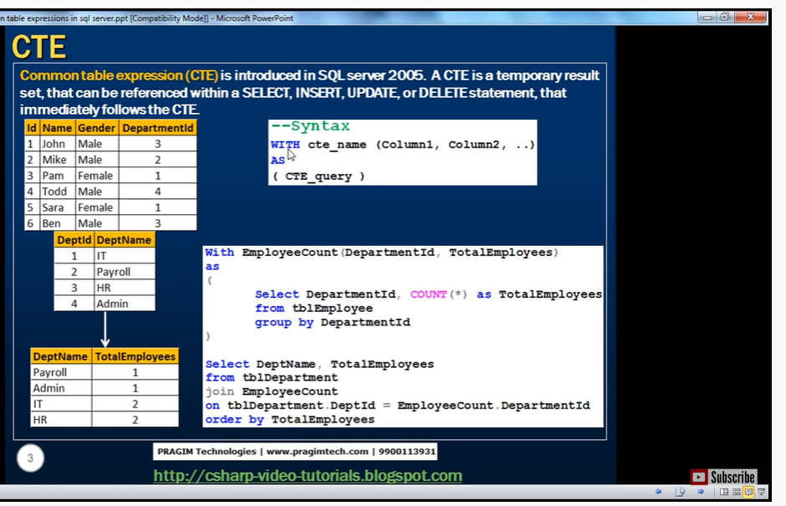

Query result – columns- that we specify beside cte name in paraptosis

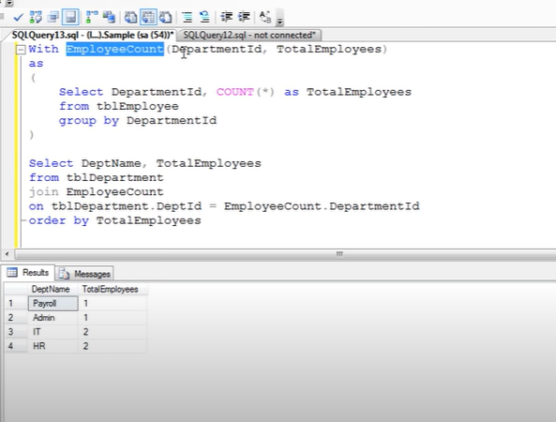

Not req column names beside cte

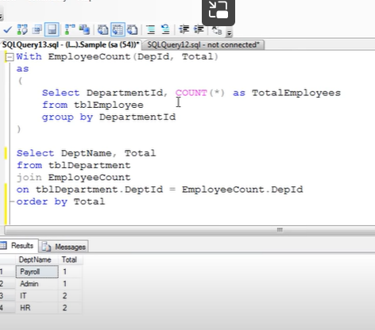

Number

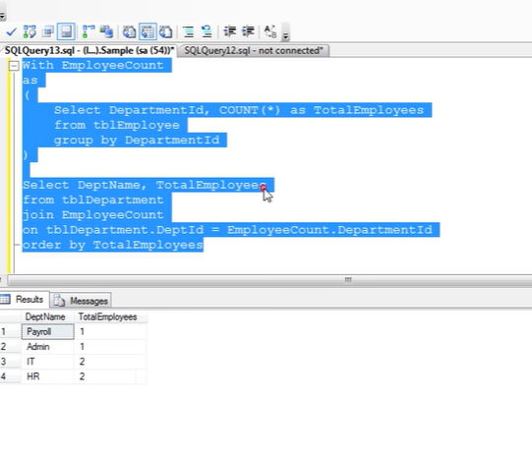

Number of columns beside cte should match with number of columns that ur select query has

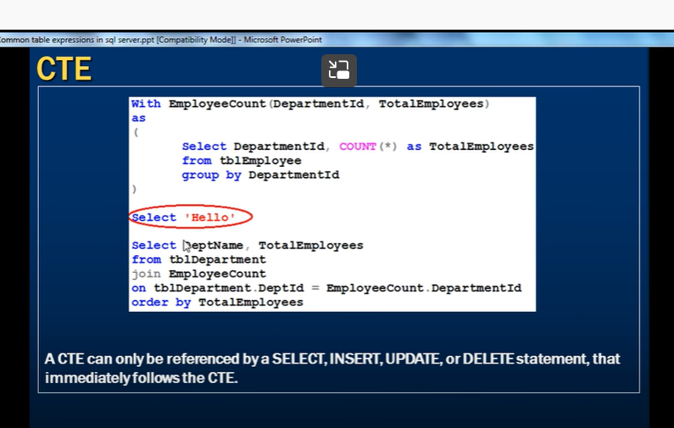

If we use another select without referring to ctc Like hello, info of cte will be gone, because ctc will be available only to immediate select statement after cte creation

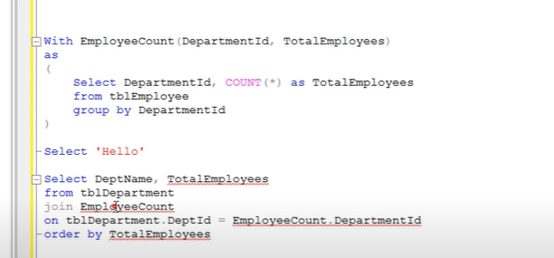

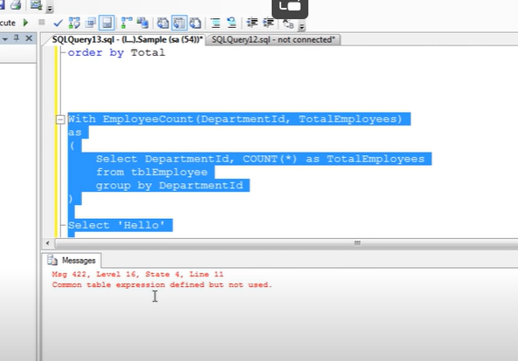



--

We can also create multiple CTE with single with clause

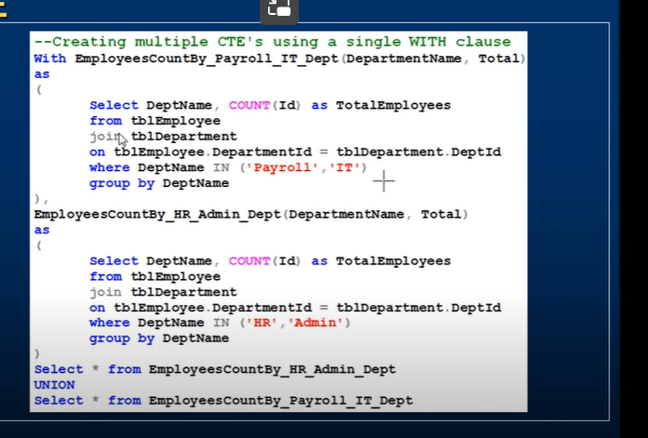

Put coma

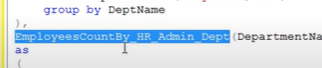

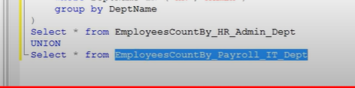

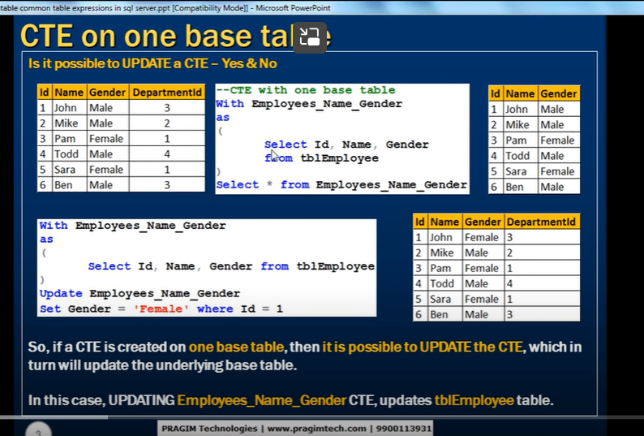

We can update cte if its created with one table – it interns update underline table

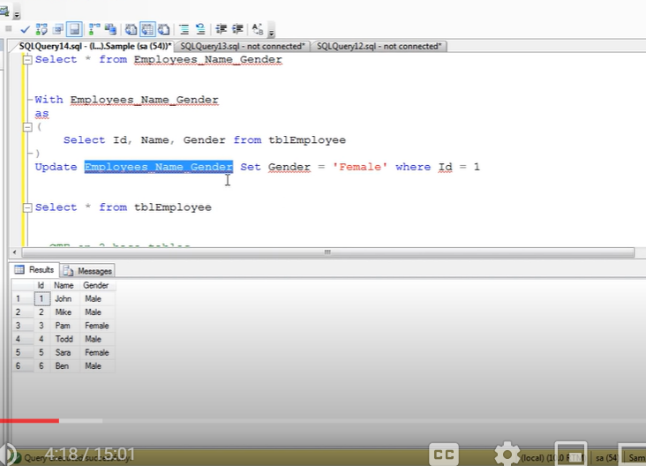

--

If CTE is based on 2 base table-if its effect only one table – possible

If its effect both table - we cant update



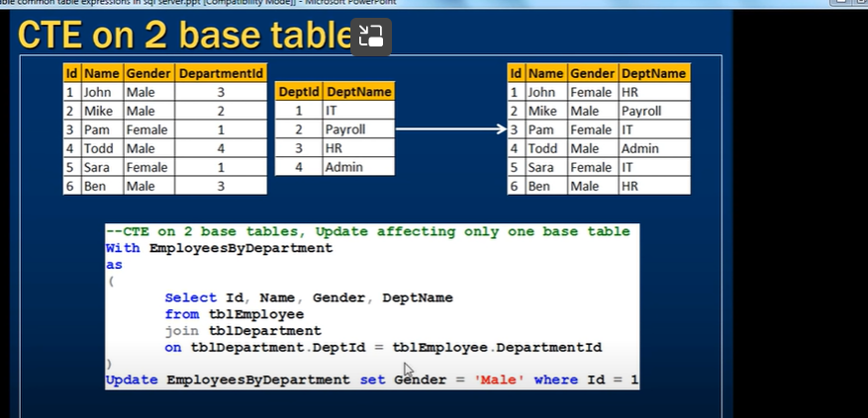

Here we are changing only gender its effect only one table- so allowed

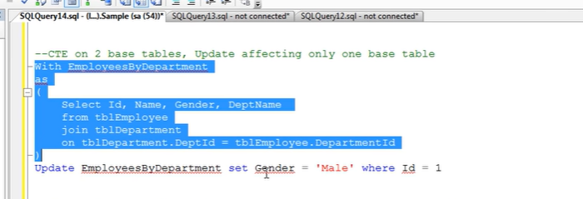

--

If update based on 2 tables or effects 2 tables

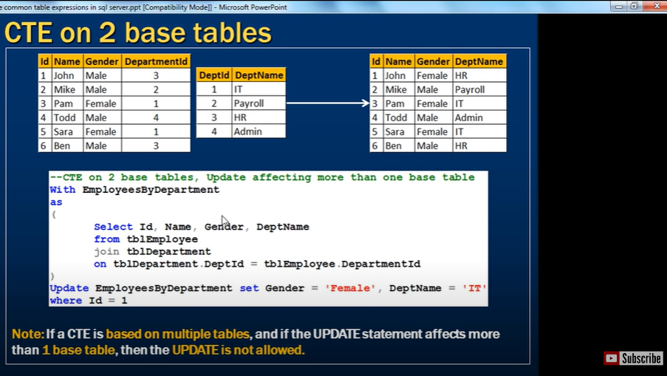

Its changing dept name as well

Below case though it changed only one table, but not in a correct way, since it changed dept name in dept table, that effects all people belongs to that particular table

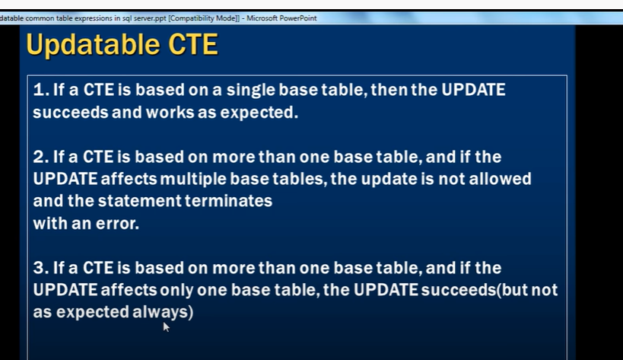

**Recursive CTE in sql server**

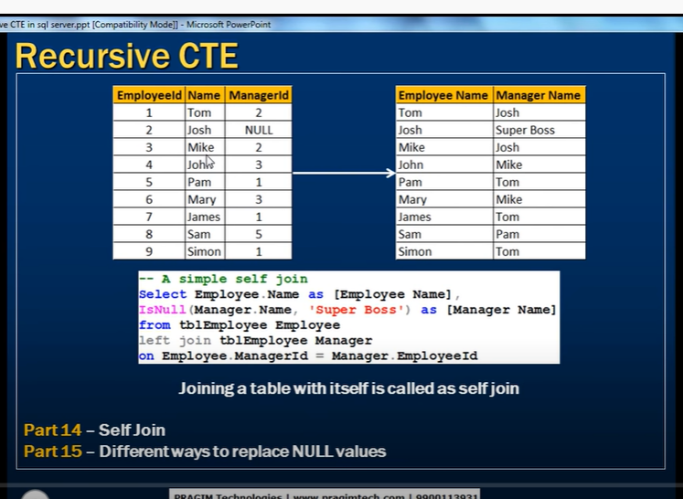

Self referencing table

If we want employee name along with manager name

Self join

Josh manager id= null – he has not having any manager – boss

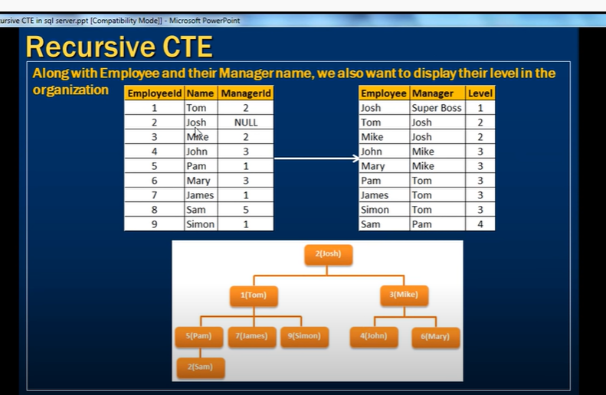

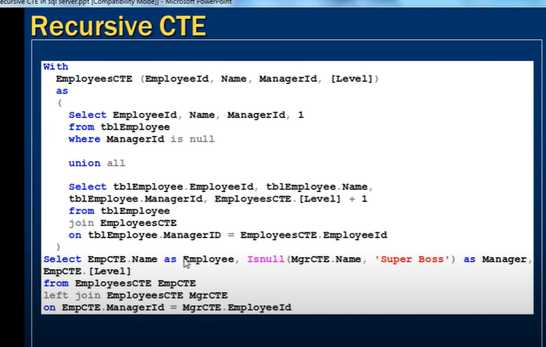

Recursive cte

Cte referencing itself is a recursive cte

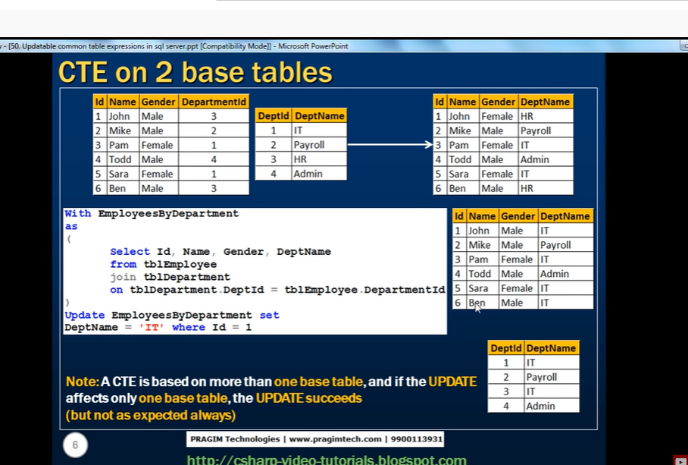

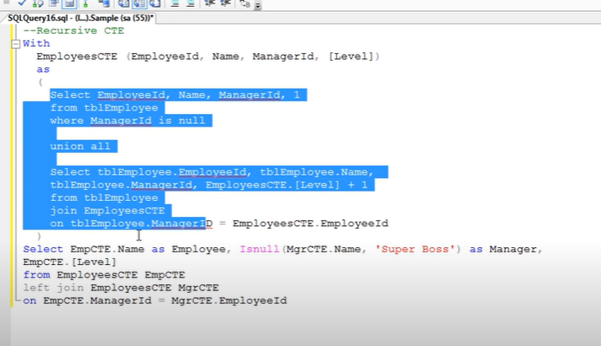

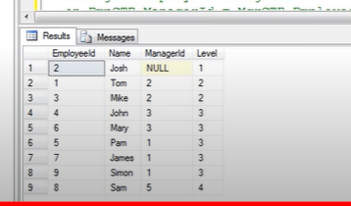

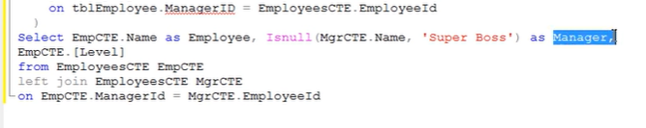

Above is self join ofcte table

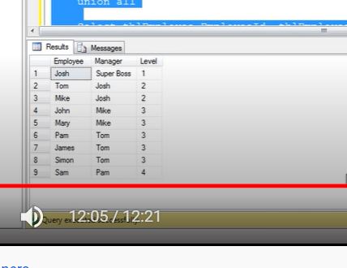

**Pivot in sql server 2008**

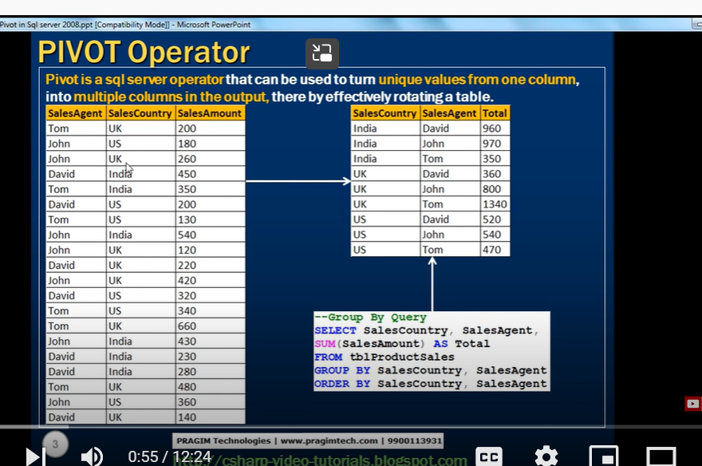

This can be better presented by cross tab format

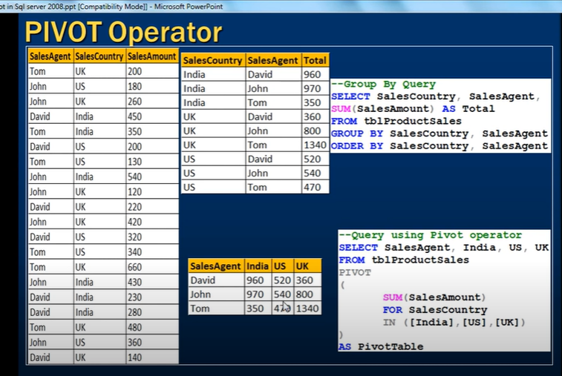

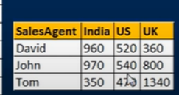

Above is cross tab format



It takes unique values from one column that is salescountry to multiple columns in output

By group by

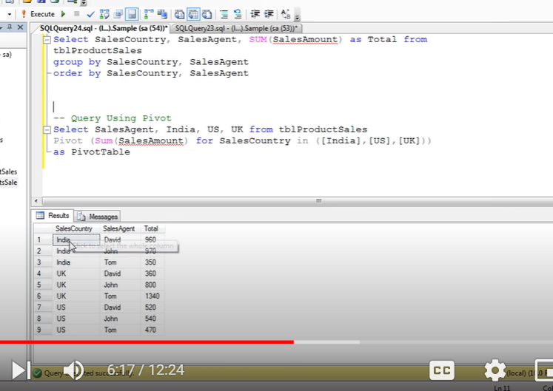

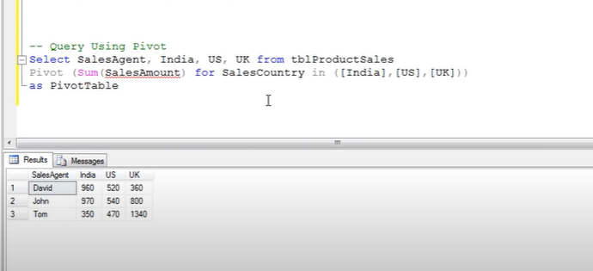

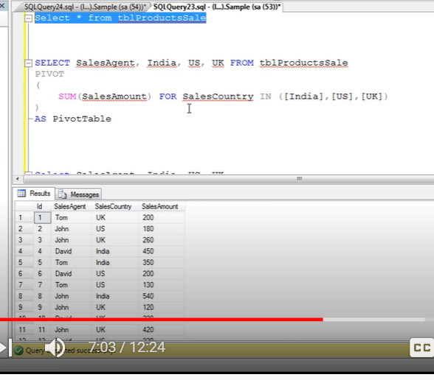

In the above example in addition we have id column as well

Because of id column result will be

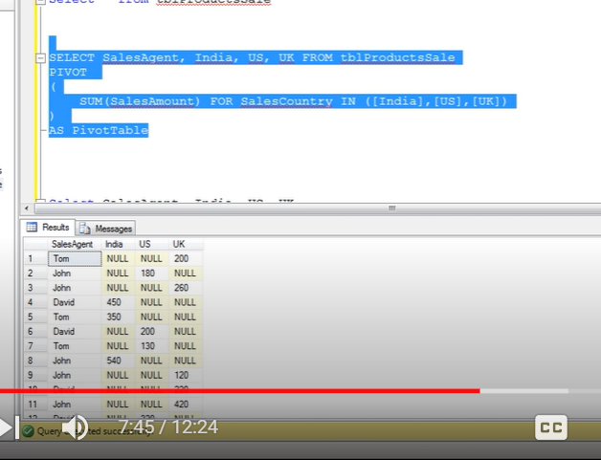

For that to correct we use derive table (select columns which we want) then pivot it

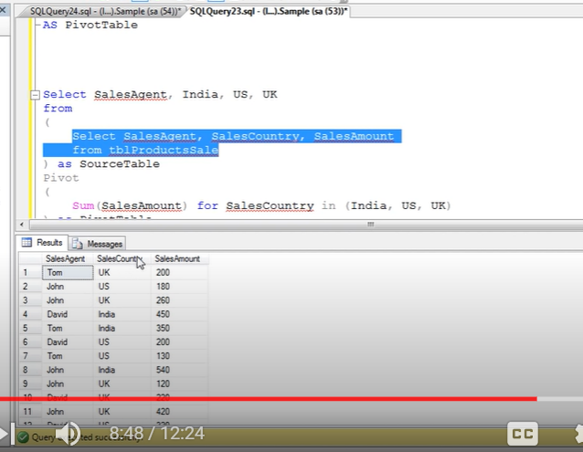

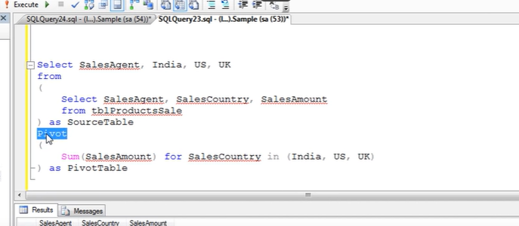

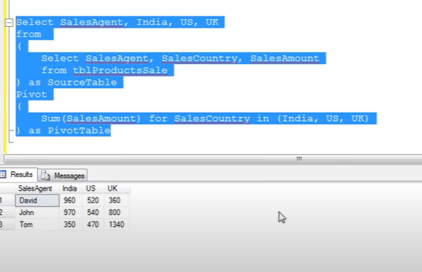

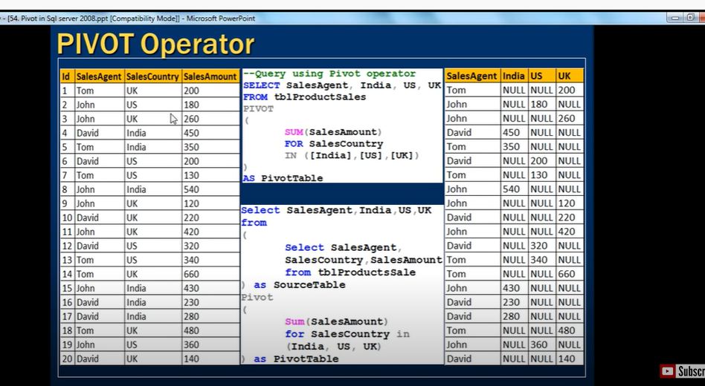

**Subqueries in sql**

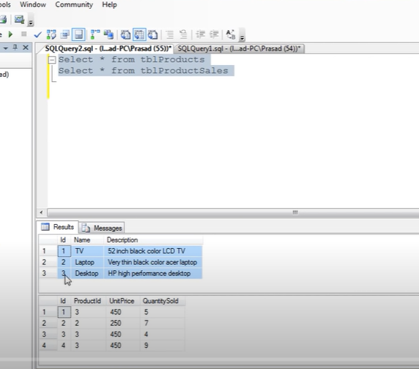

Tv we wil not sold

Find id and description which we didn’t sold

Select id, description from productstablewhere id not in (select distinct id from salestable)

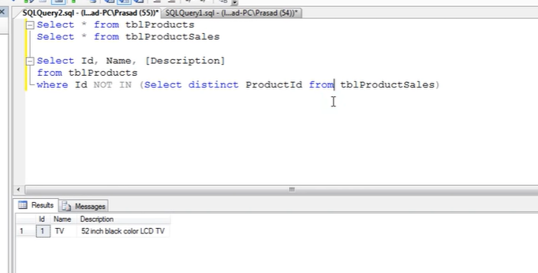

We can also do by using joins

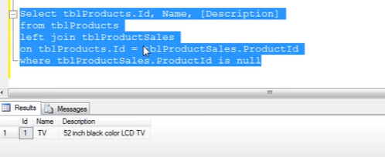



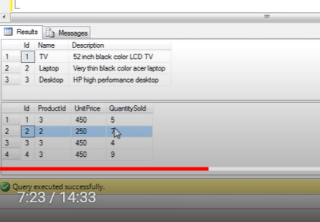

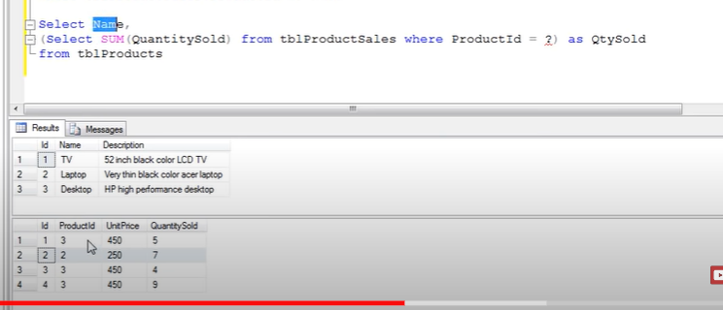

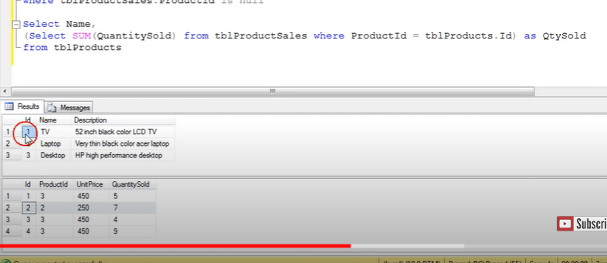

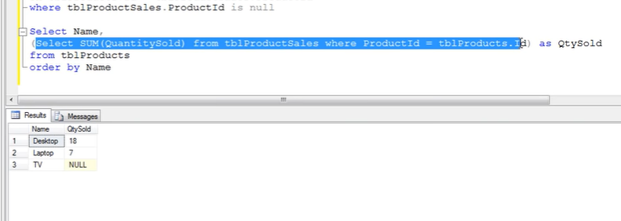

Now use with join

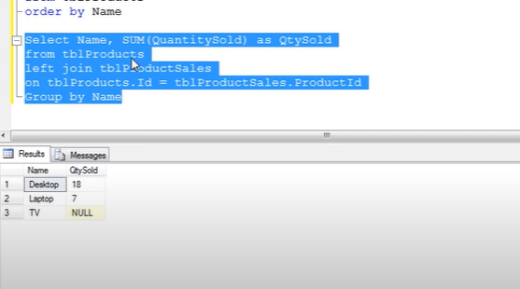



We can use in

Select

Update

Insert

Delete

Subquery may contain other sub queries

We can next sub queries in 32 levels

Sub queries always used in parenthesis – called inner query

Query that contains sub query is called outer query

The columns from a table which are present only in sub query cant be used in select list of outer query

You cant use any columns in a table which are used in sub query

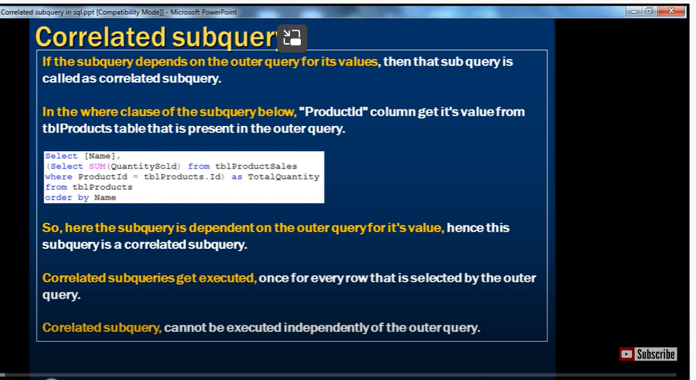

If subquery depends on out query for its value

To get products which are not sold not even once ‘

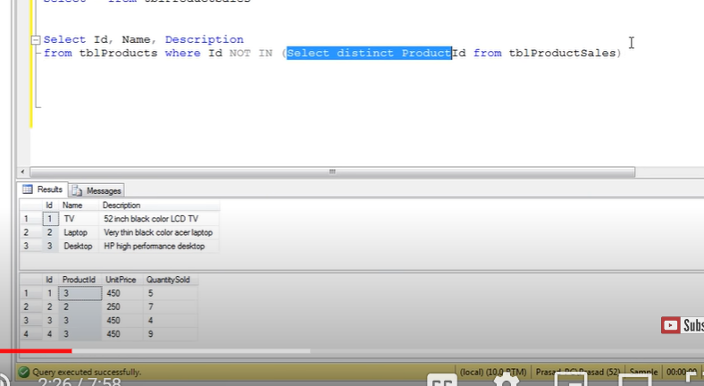

In non correlated sub query – subquery not depends on outer query, subquery executed only once

--

Now we want product name and total quantity

Select name,

(select Sum(quantitysold)) from tbl producttable where productid= tble.productid)

From tble.producttable

I cant execute subquery independently

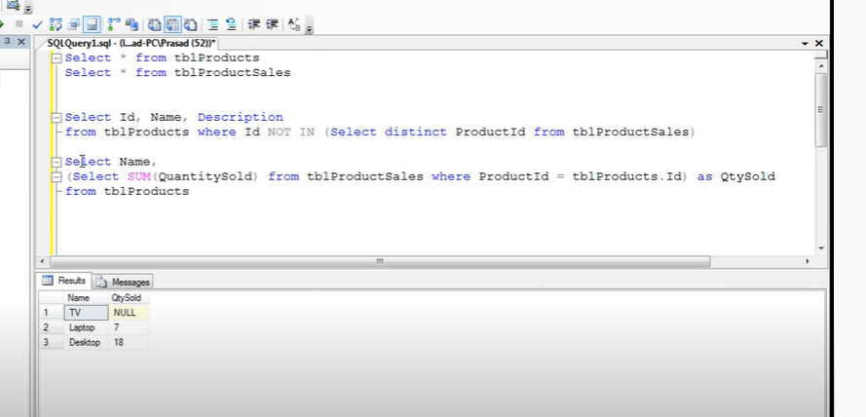

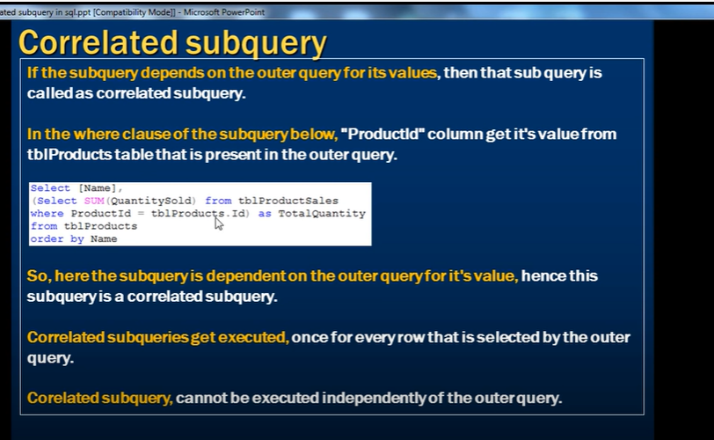

**What to choose for performance SubQuery or Joins**

List of products which are sold atleast once

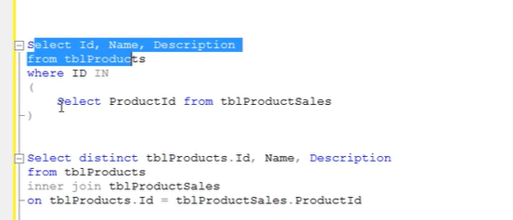

Same time for both subquery and join

If subquery has nested query then joins will work better than subquery

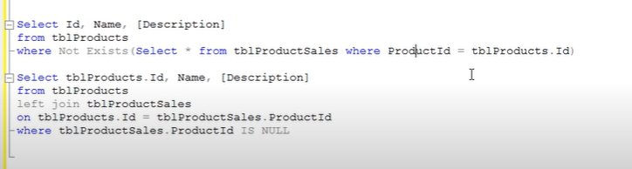

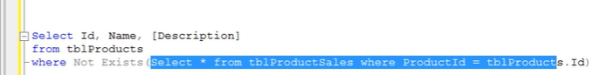

Above is nested query where existence checked

In that situation joins will perform in a better way

--

But in real time its depends on execution plan of sql server

**Cursors in sql server Part 63**

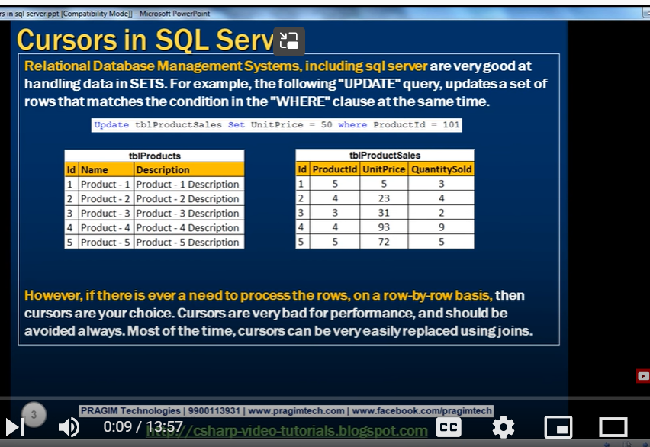

Relation ship database mag system very good in handling data in sets

Update , delete and select work efficiently in sets

If we are working data as sets(all data related to female like group of data)

--

When we want to process data row by row- then cursors will do good job

Cursers are bad , very slow as they work row by row

They can be relaced by join

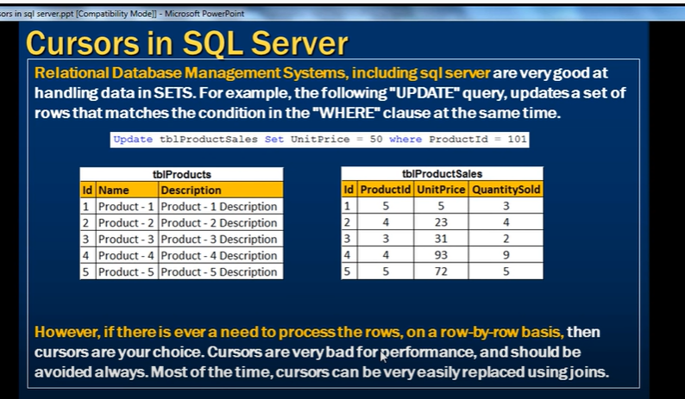

Diff types of cursors



Cursor is pointer to a row

Row by row basis

When we want to process row by row

--

For example when we want to print id and name row by row

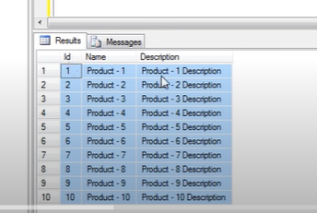

We should have 2 variables to hold id and name

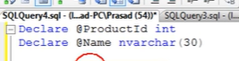

Now we should have declare key word to declare cursor

Cursor name

Then cursor for

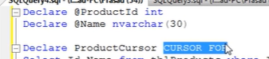

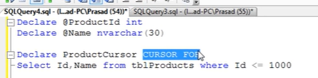

Select statement gives us result set

Pointer points to result set

--

Now open productcursor

Select statement will be excuted and retrieved to result set

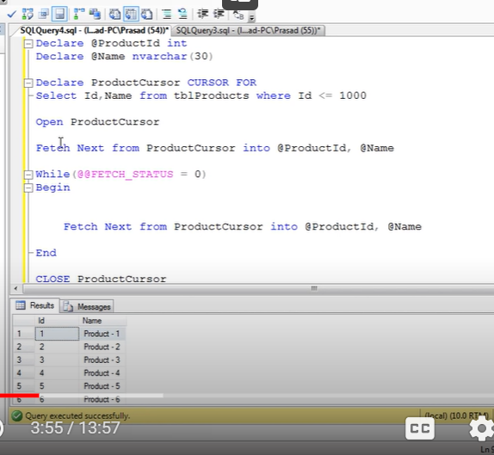

Now cursor points to above row not to eny row

When we give command like

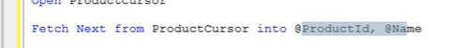

Cursor will retrieve 1st record

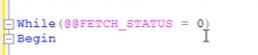

@@ fetch_status will be zero till there are rows below the cursor

Once cursor moves to last row

The status will become non zero

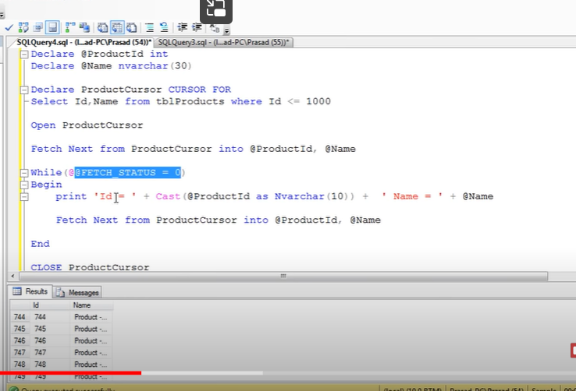

We are doing cast id to varchar since we are concatenating

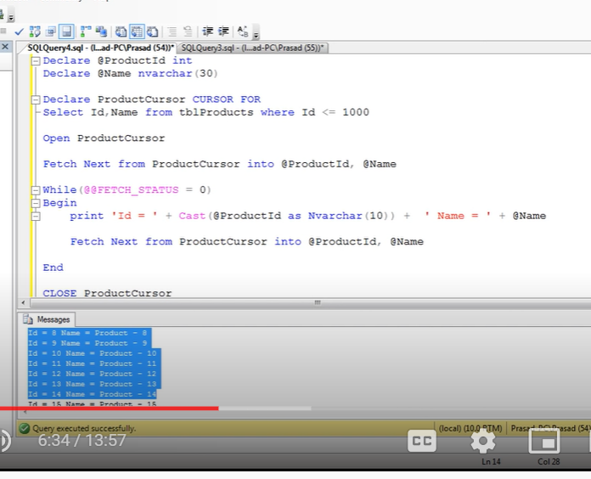

Cursor is used to loop through rows

Example:

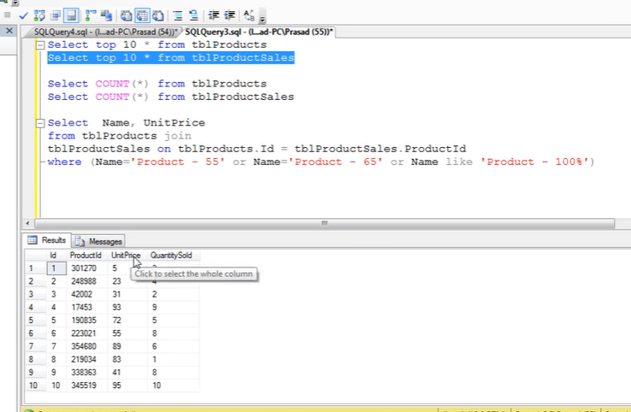

When I want to update unit price

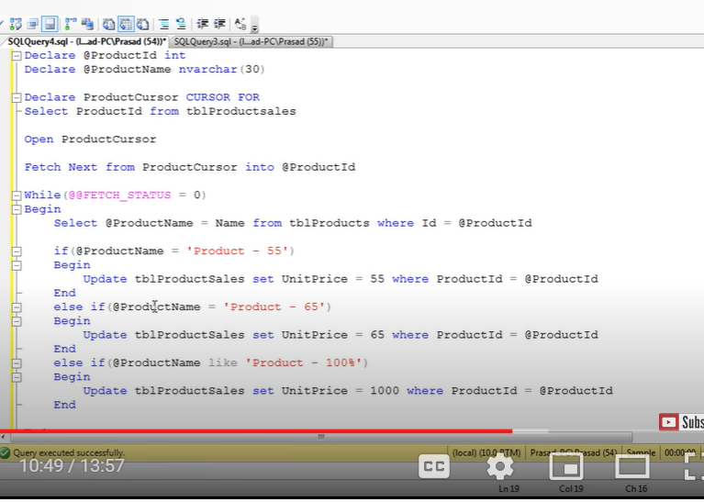

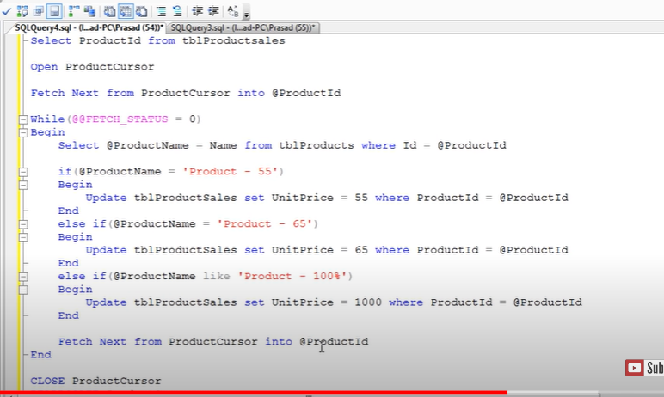

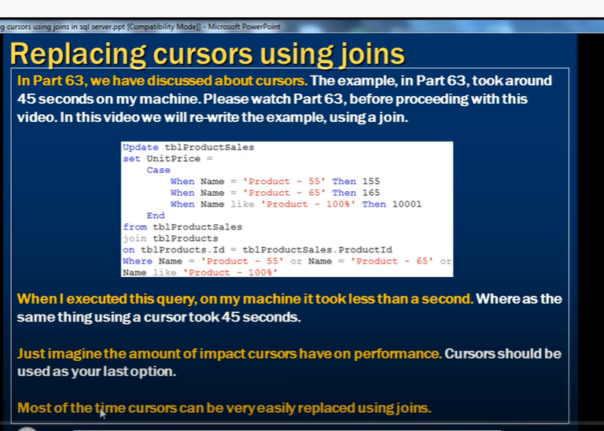

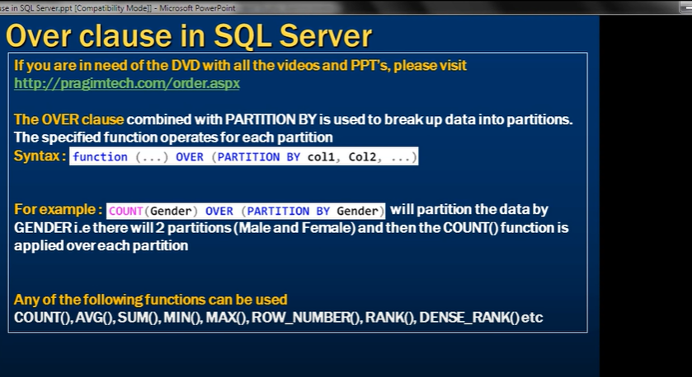

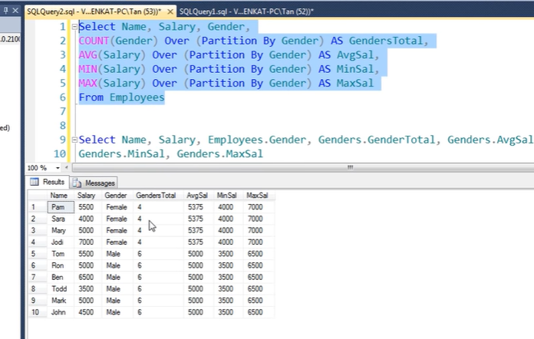

Row number:

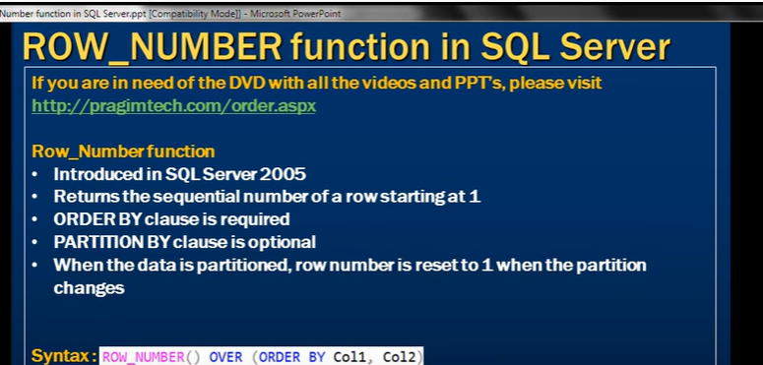

Order by is required

Partition is optional

When data is partitioned, row number reset to 1 when the partition changed

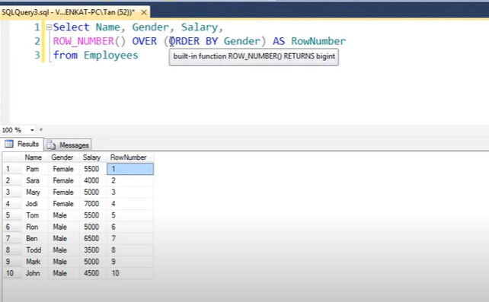

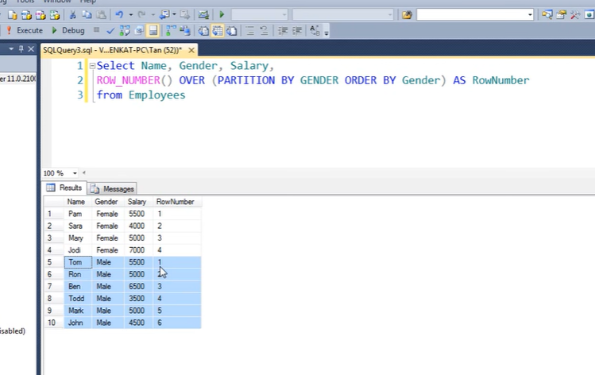

Use case:

Deleting all duplicates except one

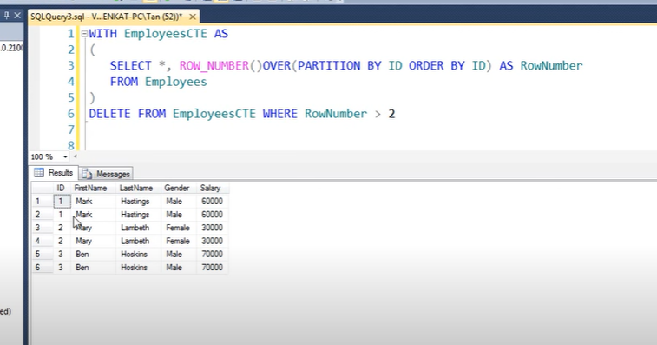

**Rank and Dense Rank**

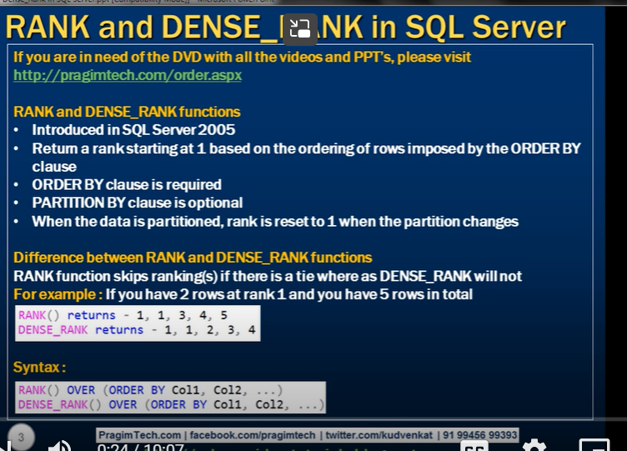

Oderby compulsory

Partition is option

Rank reset to 1 once the partition changes

--

Diff rank and dense rank

Rank function skip rankings if there is tie

Dense rank doesn’t skip



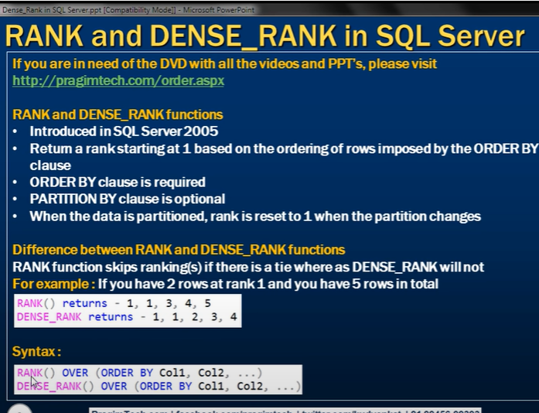

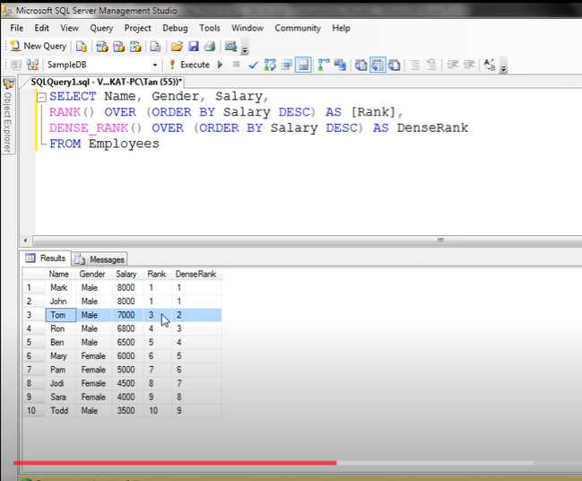

Now with partition

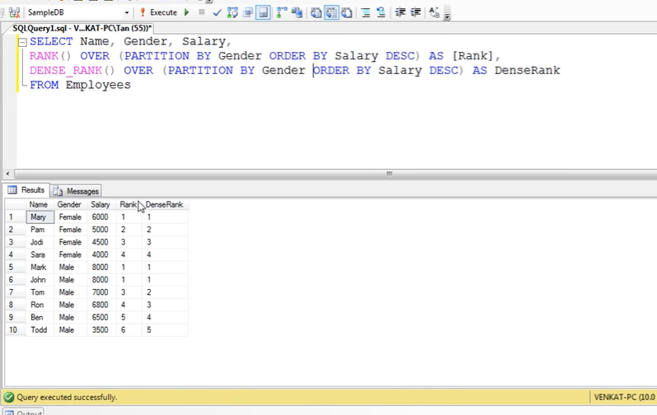

Use case

Nth highest salary

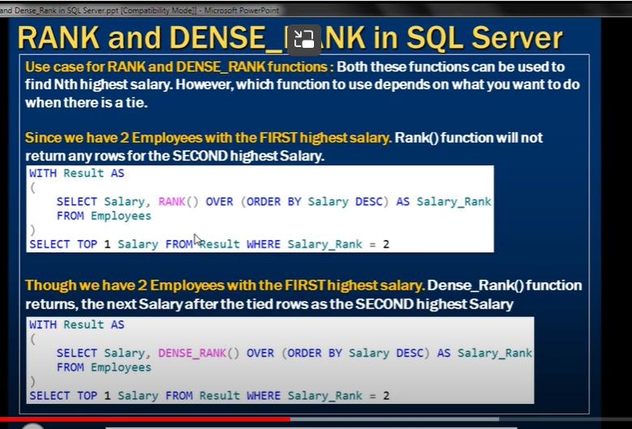

If 2 employees with2 highest salary (if does nt require second highest then rank)

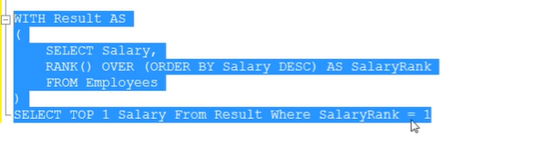

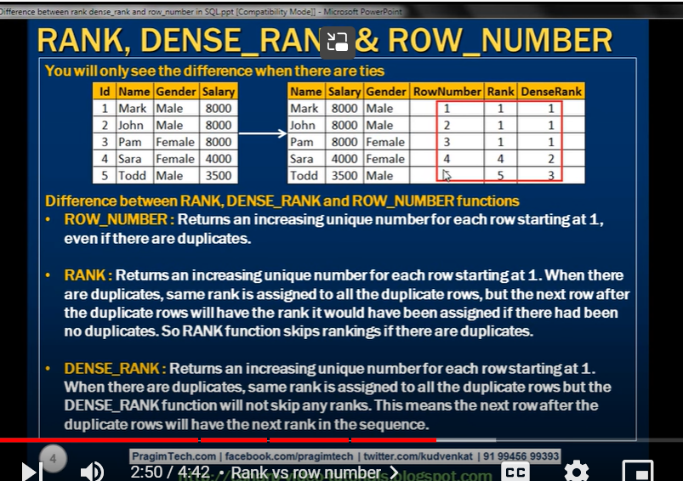

**Calculate running total in SQL**

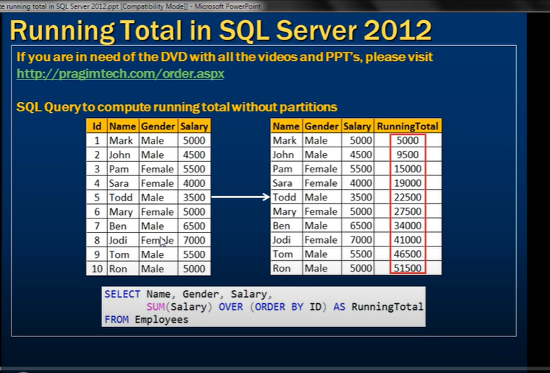

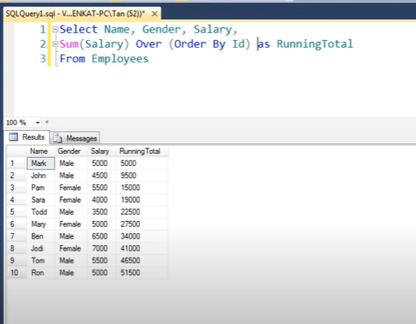

Why should we use salary column in over not salary

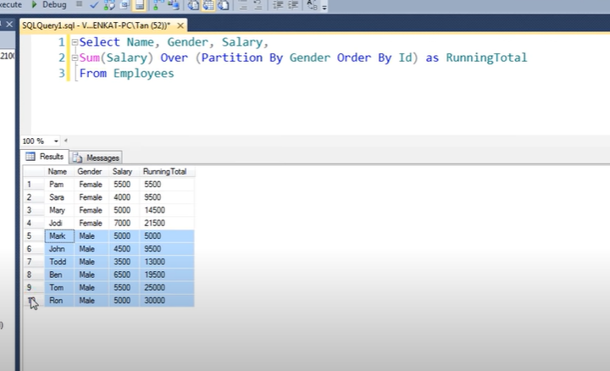

Separate running total for both males and femals

Why are we not using salary column

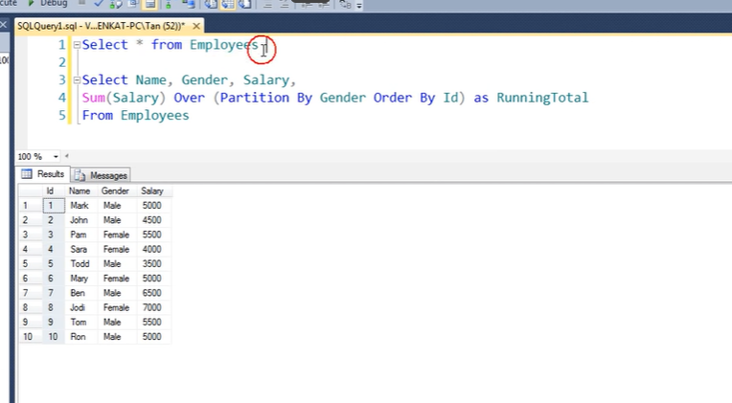

Above is raw data

Id is primary column, data in this column is unique

Where as salary has duplicate columns

If we use salary column inn order by clause

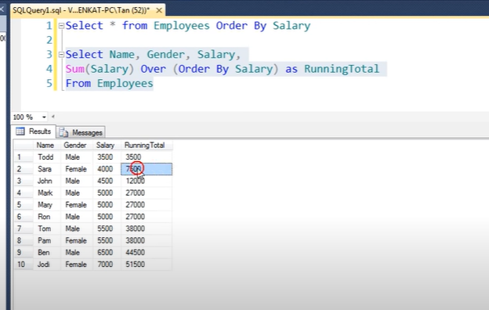

Directly 12000 to 27000

It adds all 5000 at a time

**NTILE function in SQL**

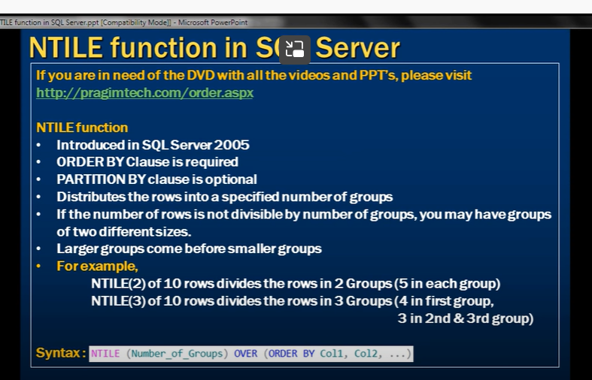

Distribute rows into number of groups

If we have 10 rows- 2 groups- each group 5

If 3 groups- 4 in first group, 3, 3 in 2nd and 3rd groups



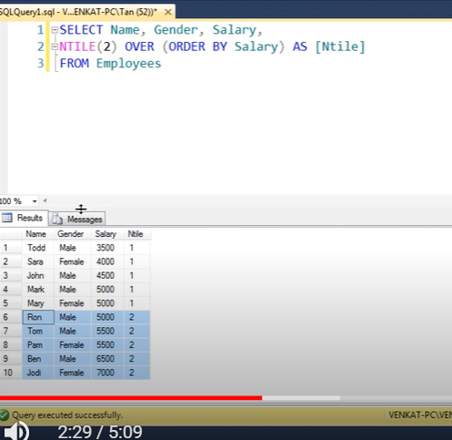

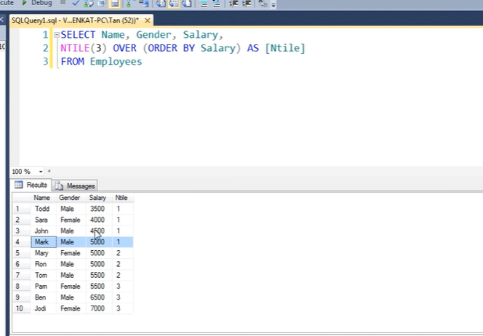

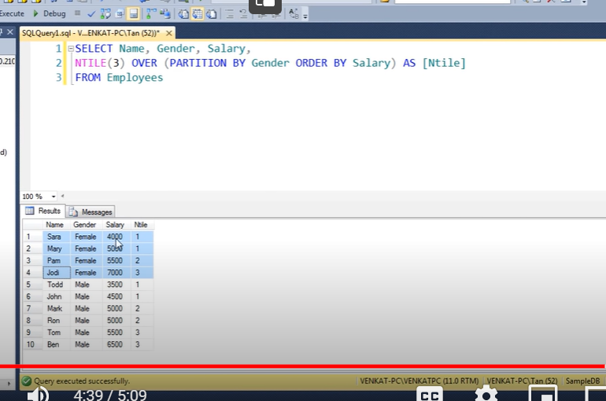

First devide groups

Order

Then ntile

**Lead and Lag functions in SQL**

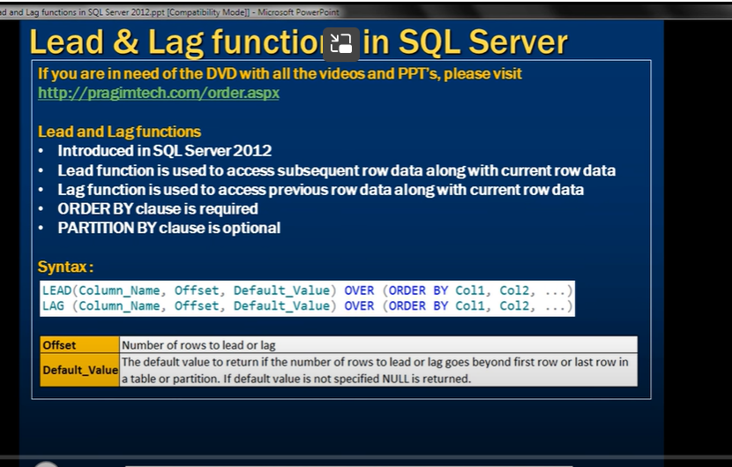

Lead subsequent

Lag: previous row data

Order by is requires

3 paameters

1. Column name on which lead or lag should be
2. Off set: number of rows to lead or lag(default 1)
3. Default value ( if not specified , null) last and first row value

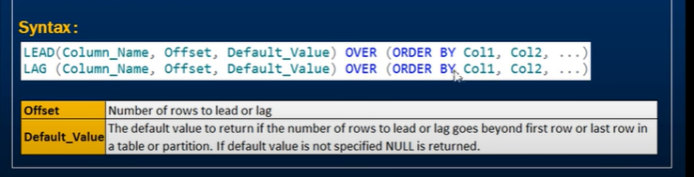

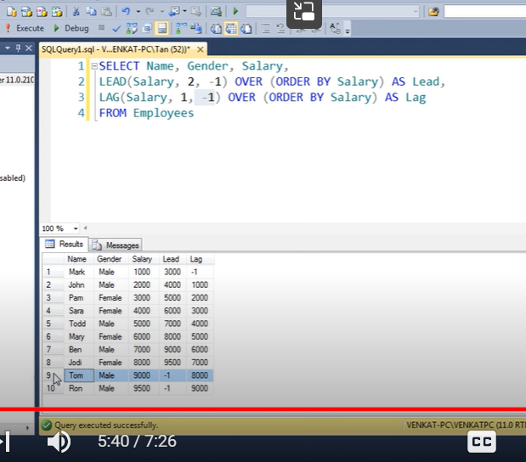

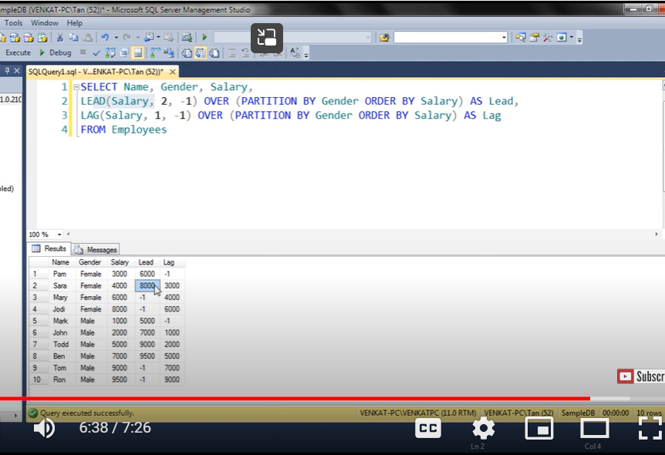

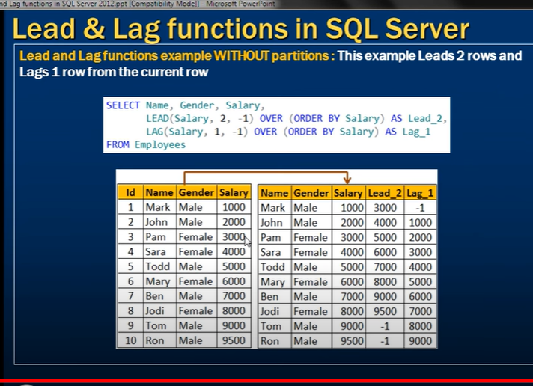

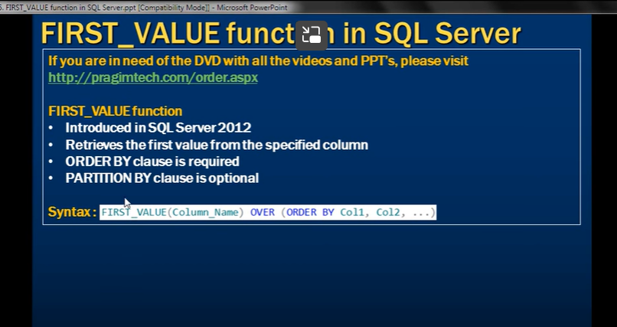



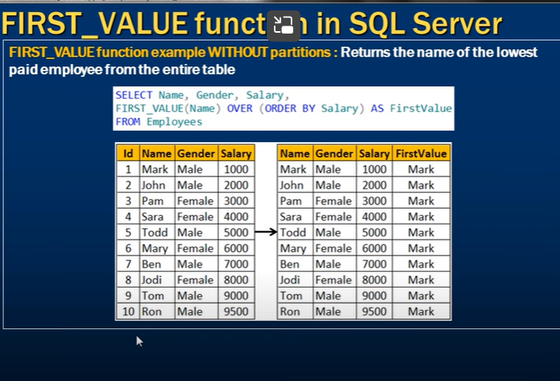

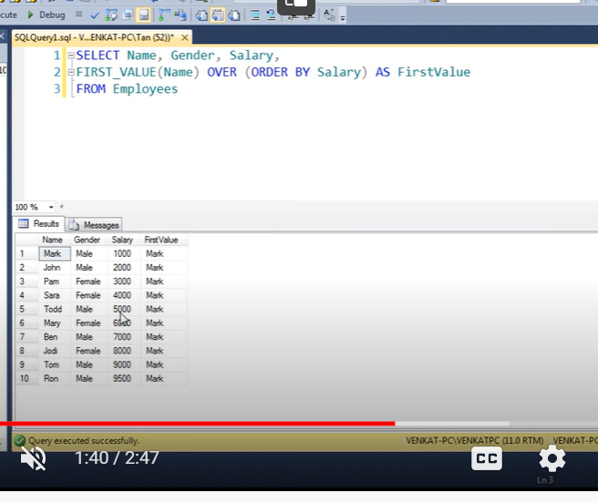

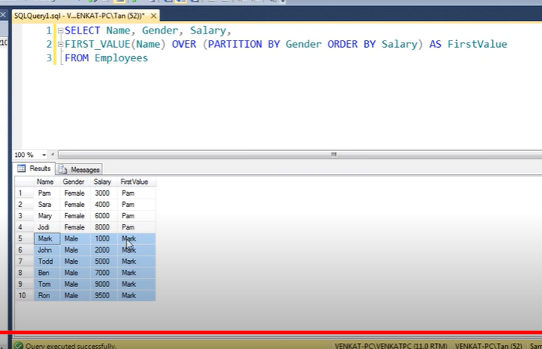

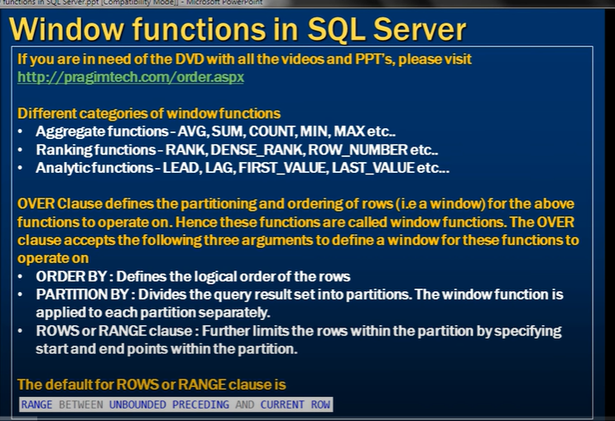

Window

Aggregate

Rank

Analytical

We can use over clause- defines order and partition

Over – 3 arguments

Orderby

Partition

Rows or range

Rows and range:

Default



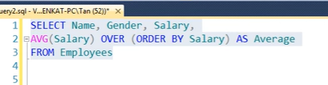

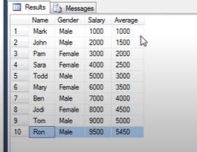

We got final avg at the end

Since we didn’t specify explicit value of row or range in over

Its taking default value of



Range between unbounded preceding(starting from beginning) to current

That’s y

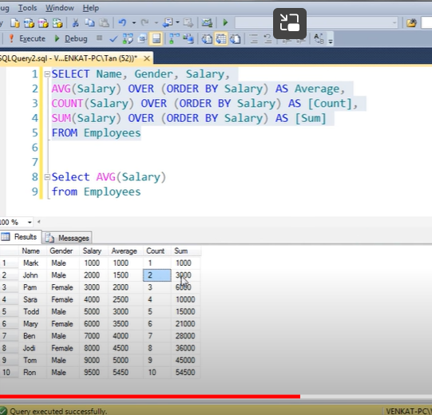

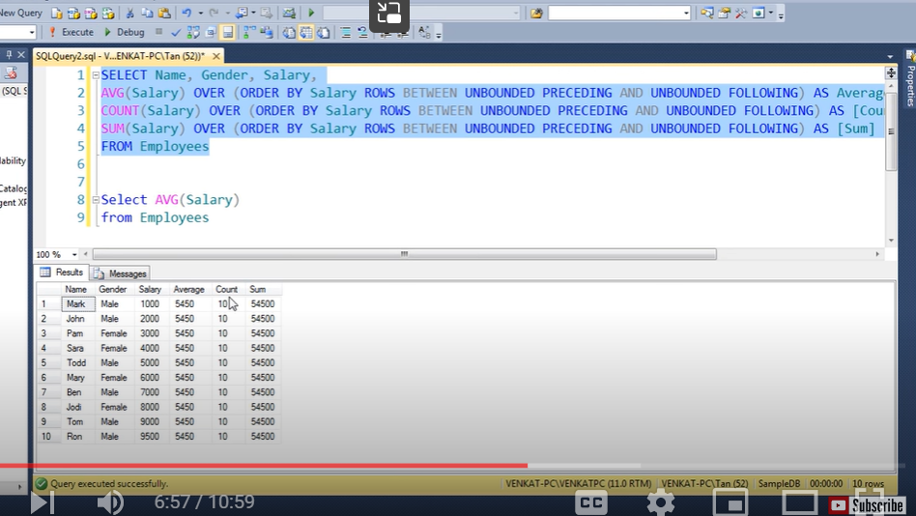

We must use unbounded preceding to unbounded following

**Difference between rows and range**



Running total

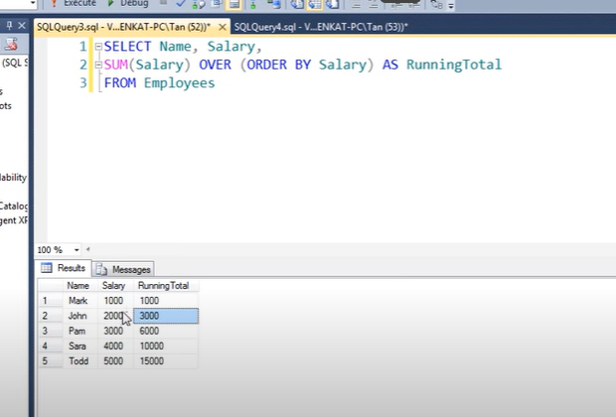

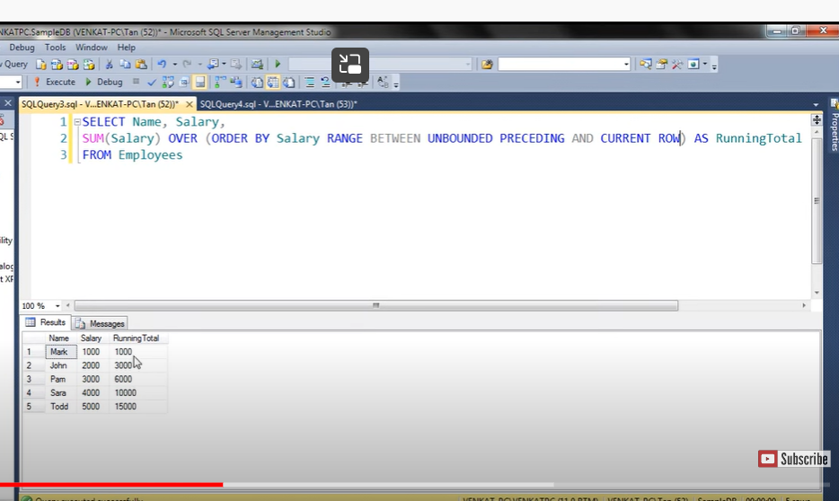

**Range and row:**

How duplicated have been treated

Deafault is range

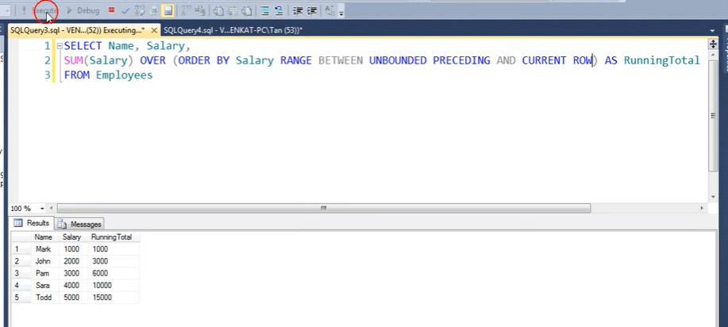

So we can write query either with default value or without

Now use row

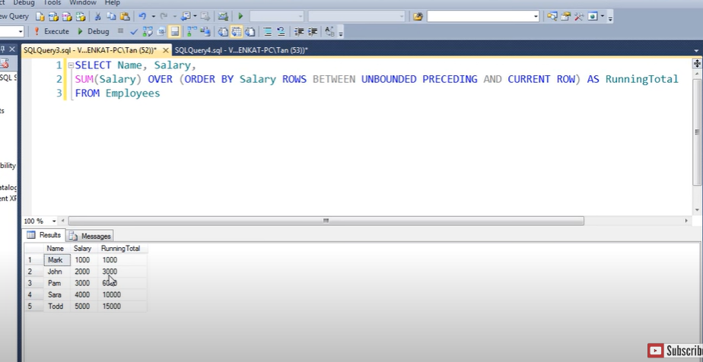

It gave same result as row and range are same if no duplicate records

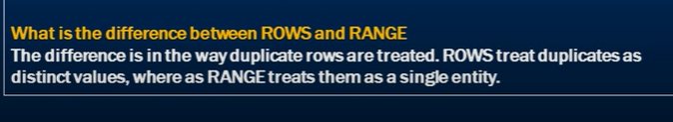

Rows – duplicates as distinct values

Range treats single entity

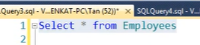

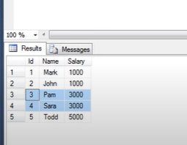

It has duplicates

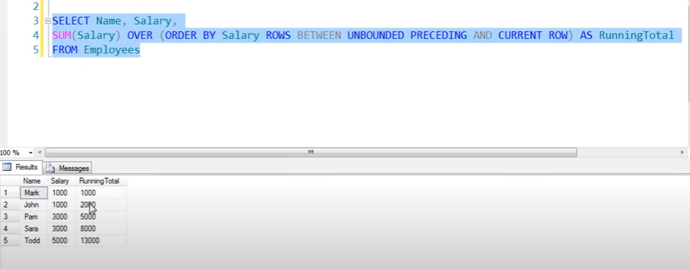

Row calculates running total eventough duplicates

Now range

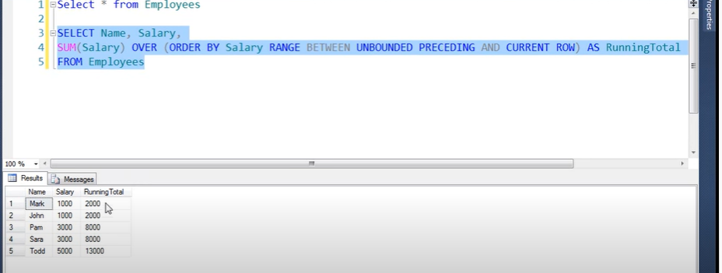

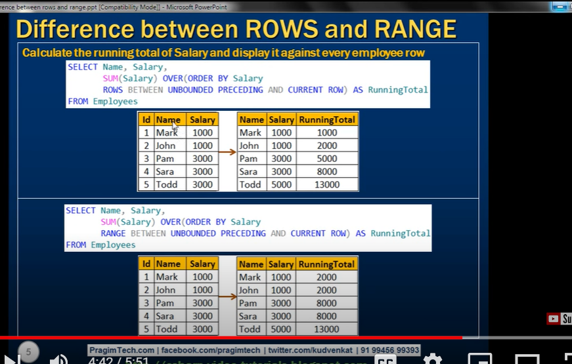

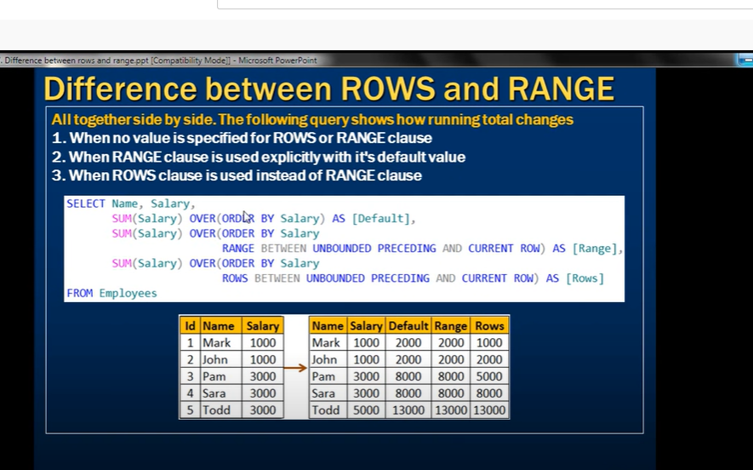

**LAST VALUE function**

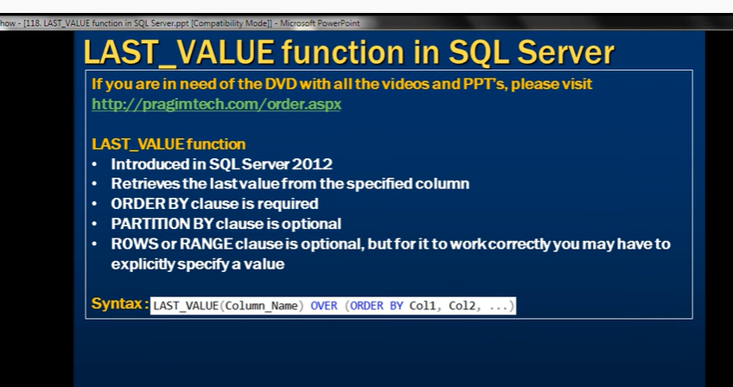



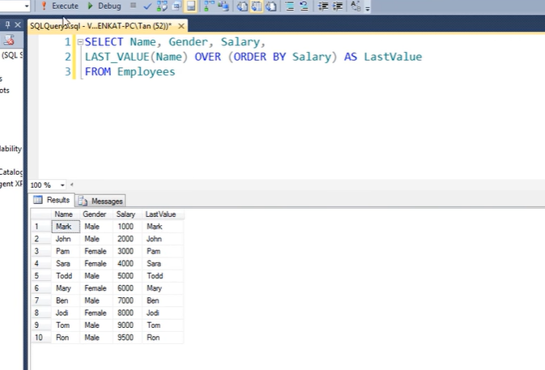

Since we have not specified range or row

It uses default range between unbounded precedings and current row

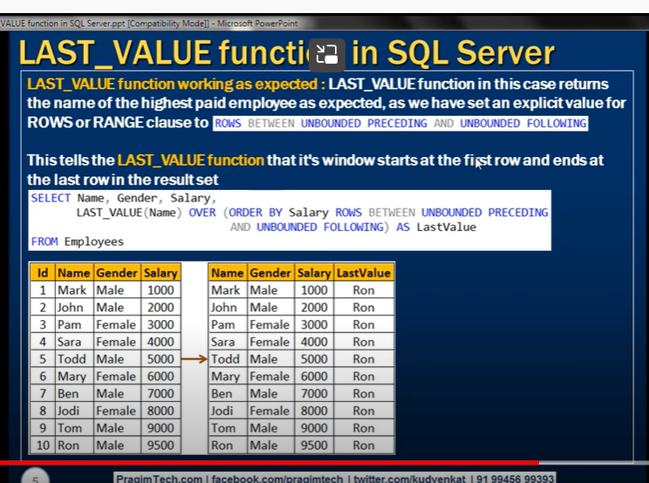

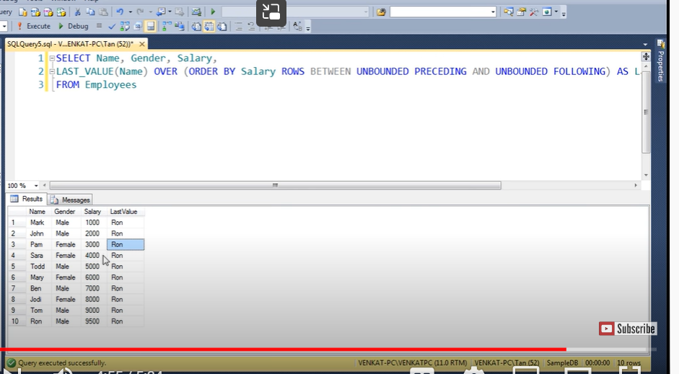

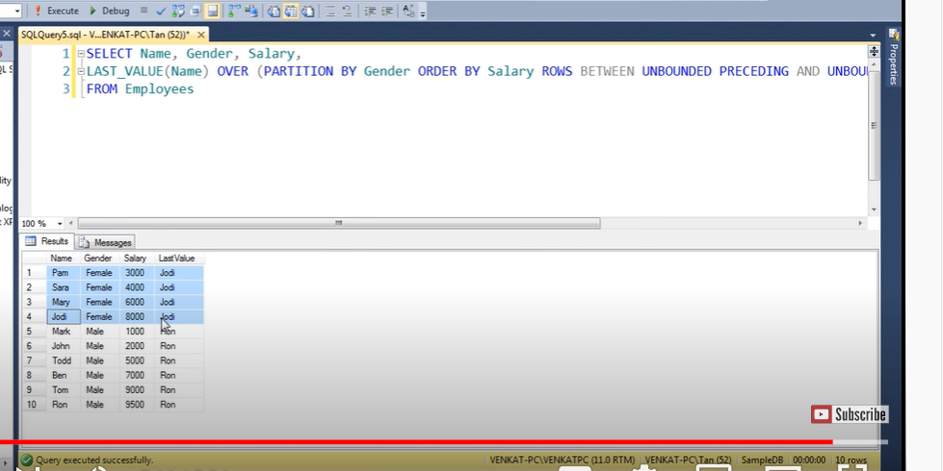

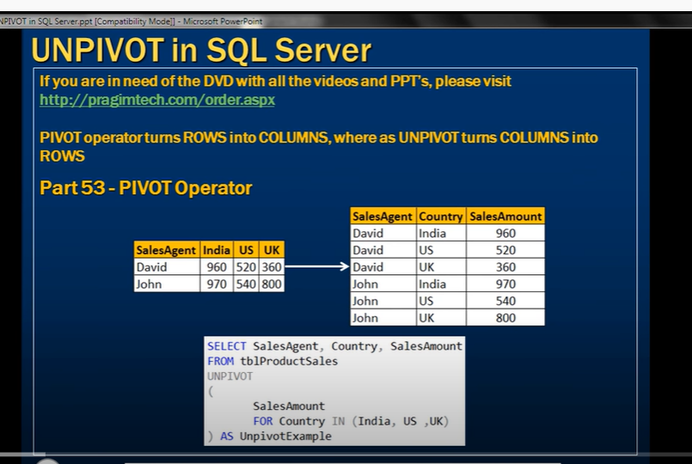

Pivot table converts rows into columns

Where as unpivot table converts columns into row

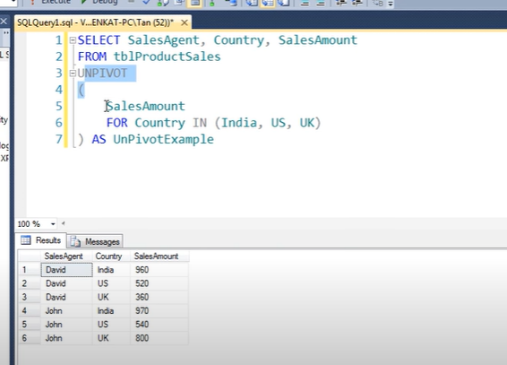

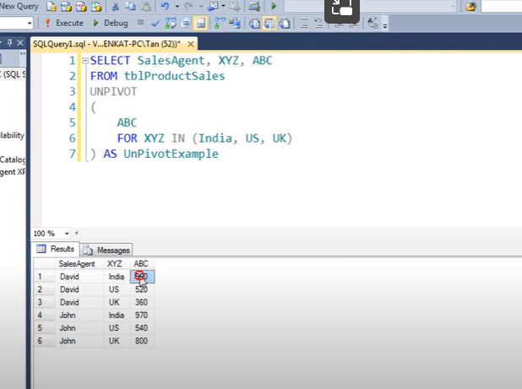

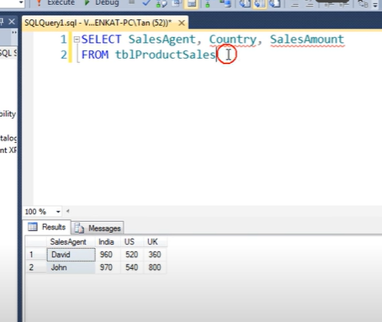

We don’t have names amount and country in pivot table

We will get it by unpivot

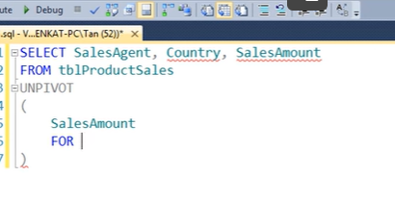

Now unpivt country column

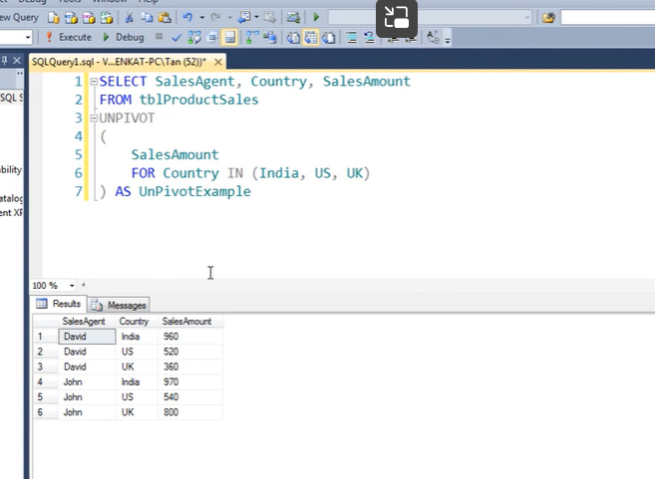

**Reverse PIVOT table in SQL Server**

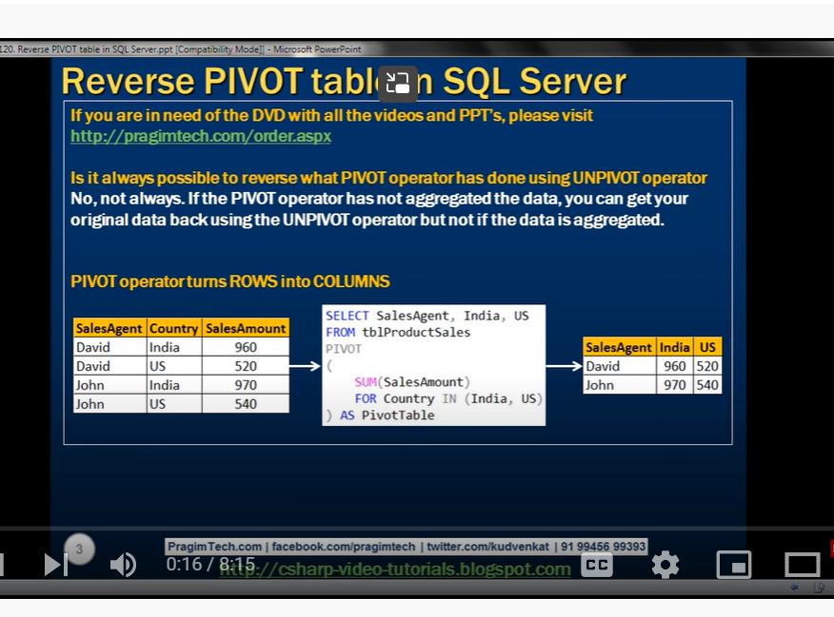we can get original data if pivot table is not aggregating

